Lesson 05 Introduction To FlexBox Hands On

**Lesson 5 Practice Hands-On**

**Directions**

For your Lesson 5 Practice Hands-On, you will be practicing your new skills working with Flexbox. This Hands-On will not be graded, but we encourage you to complete it. The best way to become a great programmer is to practice! Once you have submitted your project, you will be able to access the solution on the next page. Note that the solution will be slightly different from yours, but should look similar.

Setup

1. Open up your terminal/command prompt.
2. Navigate to your desktop in your terminal.
3. cd Desktop
4. Next, navigate to the FullStackWeb directory in your terminal.
5. cd FullStackWeb
6. Then, navigate to the FrontEndFoundations directory in your terminal.
7. cd FrontEndFoundations
8. Create a new project folder named L05HandsOn located within the FrontEndFoundations folder in your terminal.
9. mkdir L05HandsOn
10. Once the process is complete, navigate into the L05HandsOn directory:
11. cd L05HandsOn
12. Run the following to open your new project in VS Code (or you can open the folder within VS Code directly):
13. code .
14. Create two new files: index.html and style.css in VSCode by selecting the add file button shown below:

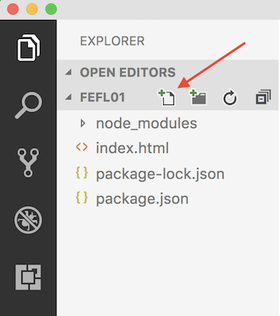

1. Link your CSS file to your HTML file using <link rel="stylesheet" href="style.css">

Requirements

Step 1

* Give your page the following:
  + Header
  + At least ten (10) images
    - Use Flexbox to center and evenly space your images accross the page.
    - If your images are large and don't all fit in one row on the page, they should wrap down to another row so in the end, it looks like a grid of pictures.
* Style your page to your liking

Example

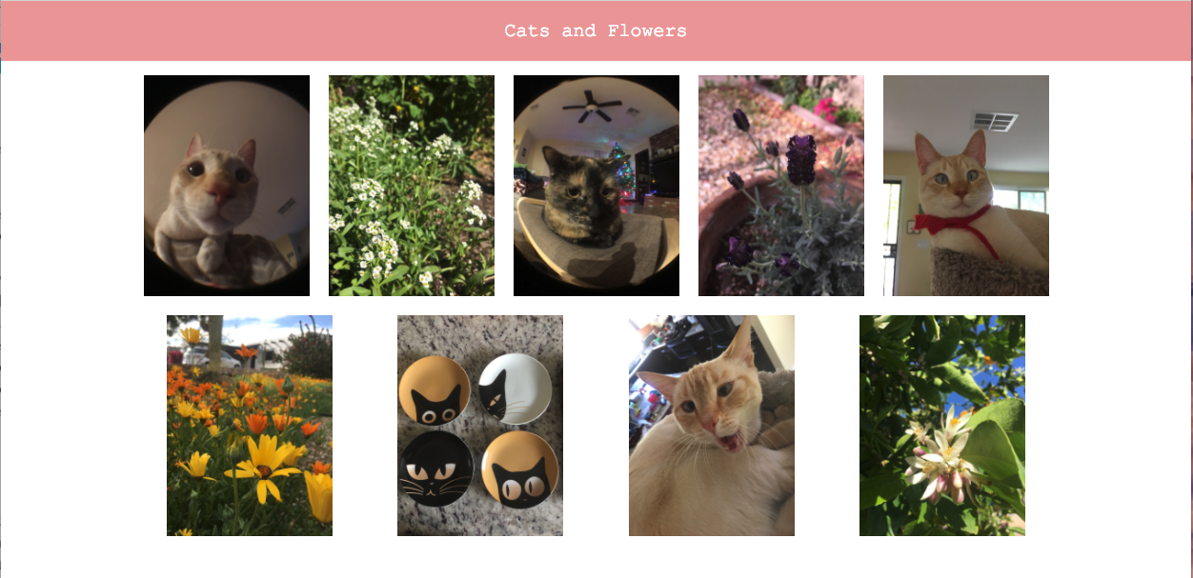

Caution!

Be sure to zip and submit your entire L05HandsOn directory when finished!